PODEM review:

PDEM: Path Oriented Decision Making

It’s an ATPG technique. ATPG is generally a fault oriented method and this is not related to what it is mentioned in the name of the PODEM.

* Employs direct search technique.
* Concept of “**Justification**” does not exist anymore and it is replaced by “**Backtracing**”.
* Assignment of value Vk on net k becomes an **objective** (k, Vk) which should be achieved by assignment of PIs.
* First objective is activate the targeted fault.
* Backtracing procedure is used to solve this objective. This means we traverse back from line k to a PI over signal lines having value X, or in other words, lines which values are not determined yet.
* Backtrace procedure of object (Vk, k) return with two information. First is the value of PI (Vi), and the other one the path form that PI to k with its parity along this path. So assignment of PI to Vi is **likely** to force line k to Vk.
* Parity (P) of the path is defined as $p=Vi ^ Vk$.

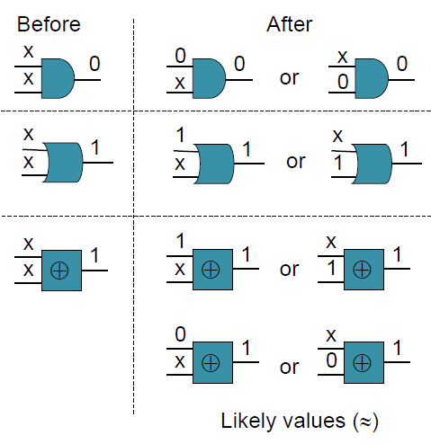

* Likely input (Vi) of a certain output (Vk) is as follows:
  + Vi = Vk ^ I (inverting value of the gate K)
* First, define the first objective to activate the targeted fault, e.g. if fault is SSA1 at net K, the initial objective is (0, K).
* If a PI sets a line to the opposite value than desired (mostly on forward implication after backtracing), then the value on the PI line is flipped.
* Backtracking may also happen.
* Backtracing Pseudo Code is written!